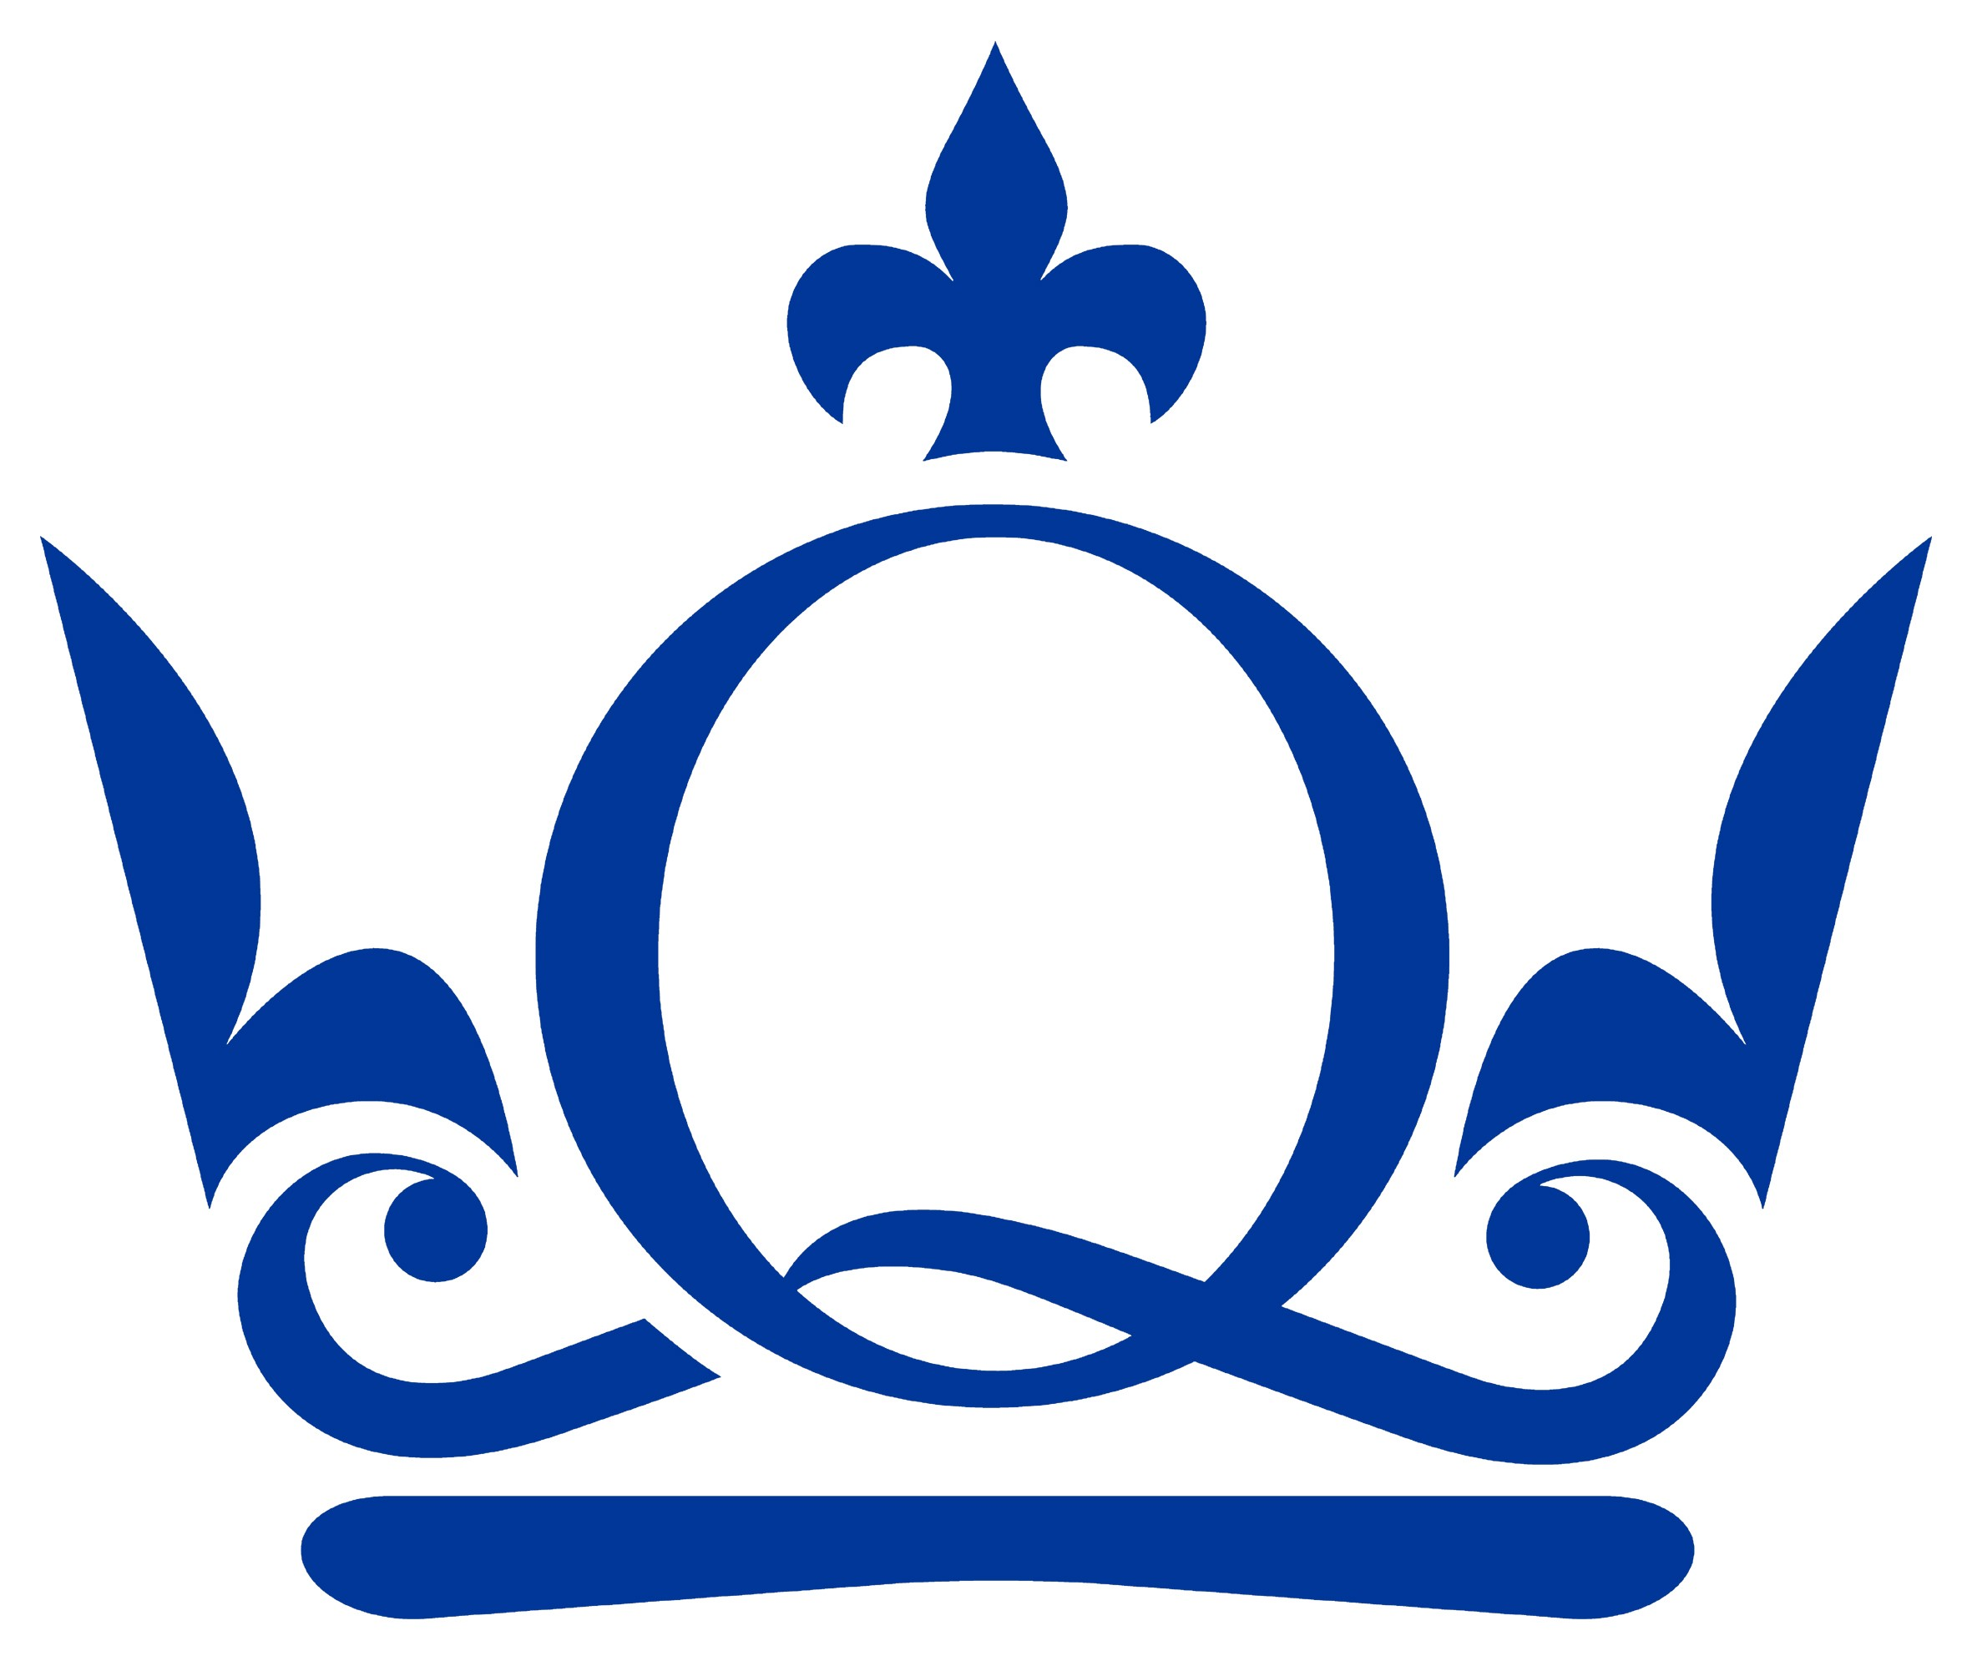Job Profile
Core job information
DiVA is the independent training provider for creative media professionals. Our core work incorporates creative apprenticeships, graduate work placements, accredited and non accredited training as well as career coaching.

We work across the creative sector including film, TV and digital media, arts and culture with clients’ including large corporations such as 20th Century Fox, Universal, Crossrail to start up businesses.

DiVA has an excellent track record of supporting learners and employers in the delivery of work experience placements, including apprenticeships. We were the first London based training provider to receive the Creative Skillset Tick recognising the outstanding industry relevant training DiVA provides.
Job Title | Marketing Assistant
Dept./School/Inst. | DiVA |  | Section/Centre/Unit | Marketing
Career Family | Training Provider
Working hours per week | 40 |  | Appointment period | 6 months
Reports to (job title) | Director |  | Location | Stratford
Job purpose
Overall purpose of internship: to gain experience in various types of Marketing and Communications activity used by DiVA to raise the profile of the organisation and ultimately secure new apprenticeship opportunities.
Your creative skills will be used to interview creative entrepreneurs, create video assets for distribution on our digital platforms design posters, email templates and company literature. You will also plan, organise and attend student events.
Anticipated Outcomes for the internship: By the end of the internship you will have developed the skills and experience to oversee or manage a marketing campaign and/or event. You will have a practical understanding of the impact marketing and communications plays in the overall development and growth of a company. Plus, you will have had fun too!
Knowledge, Skills & Experience
 |  | - Requirements |  |  | - Essential Unless Marked ‘D’ for Desirable
Qualifications |  | - Educated to degree level or equivalent  - Relevant professional qualification (marketing) or equivalent |  |  | - E  - D
Experience |  | - Substantial experience in marketing  - Experienced writer / blogger  - Computer literate - must have a good working knowledge of Word, Excel, Powerpoint  - Knowledge and experience using design software  - Knowledge and experience editing software  - Knowledge and experience of WordPress  - Substantial office experience |  |  | - E  - E  - E  - E  - E  - E  - E
Knowledge, skills & abilities |  | - Experience of social media networking tools (Facebook, Twitter, LinkedIn  - Excellent spelling, grammar and writing abilities  - Excellent Customer Service skills  - Organised  - Inquisitive - must have the desire to solve problems on their own if need be  - Can work to tight deadlines  - Team player  - Pro-active |  |  | - E  - E  - E  - E  - E  - E  - E
Attitude & disposition |  | - Personable attitude  - A good sense of humour!  - Self motivated  - Confident - not afraid to ask questions, particularly if you're not sure what is required of you!  - Hard working  - Creatively minded – ready to put forward ideas and run with them! |  |  | - E  - E  - E  - E  - E
Freedom to Act & Decision Making (depth of control, supervision received, use of judgement & initiative, analytical ability)
Main Duties and Responsibilities of the Role
Daily tasks include, but are not limited to:
- General customer service – telephony, responding to enquiries regarding our training programmes
- Designing marketing and promotional material, including evaluation forms, company presentations
- Updating social media portals and the company website on a daily basis
- Researching content for our social media platforms
- Help manage company events; e.g securing venues, manage guest lists, booking speakers etc
- Explore links with partner organisations to deliver collaborated events
- Manage client communication tools such as bi-monthly business-to-business e-newsletter and events
- Recording, editing and uploading video content to our website and social media pages
- Keep the website up-to-date
Working Environment
This is an office based position. The right candidate will be able to develop the role according to their strengths.
DiVA is a great company to work for. We’re a small close knit team which means you’ll get to know the business inside and out and see first-hand the contribution you make. All ideas are welcomed. All opinions are heard and respected. When we’re busy be prepared to juggle several tasks simultaneously and work to short deadlines as and when required. Above all, have fun while you get the job done!

